Copyright for test papers and marking guides remains with West Australian Test Papers.
Test papers may only be reproduced within the purchasing school according to the advertised Conditions of Sale.
Test papers should be withdrawn after use and stored securely in the school until Friday June 14th 2019.


MATHEMATICS
SPECIALIST
UNIT 3

Semester One

2019

SOLUTIONS

Calculator−free Solutions

1. $w=iz-\overline{z}=i\left(x+yi\right)-\left(x-yi\right)$
$=ix-y-x+yi=-\left(x+y\right)+\left(x+y\right)i$
$∴\left|w\right|=\sqrt{{\left(x+y\right)}^{2}+{\left(x+y\right)}^{2}}=\left(x+y\right)\sqrt{2}$ units
and $\arg\left(w\right)=\tan^{-1}\left(-\frac{x+y}{x+y}\right)=\frac{3π}{4}$ only solution [4]

2. (a) (i) $f\left(-\sqrt{3}i\right)=2{\left(-\sqrt{3}i\right)}^{3}-{\left(-\sqrt{3}i\right)}^{2}+6\left(-\sqrt{3}i\right)-3$
$=2\left(3\sqrt{3}i\right)-\left(-3\right)-6\sqrt{3}i-3=0+0i$
(ii) $\overline{z}=\sqrt{3}i → \left(z-\sqrt{3}i\right)$ is another factor
(iii) $2z^{3}-2z^{2}+z-3=0$
$∴\left(z+\sqrt{3}i\right)\left(z-\sqrt{3}i\right)\left(az+b\right)=0$
Leading term: $az^{3}=2z^{3} → a=2$
Constant: $\left(\sqrt{3}i\right)\left(-\sqrt{3}i\right)\left(b\right)=3b=-3 → b=-1$
$∴2z-1=0 → z=\frac{1}{2}$
Solutions $z=±\sqrt{3}i,\frac{1}{2}$

(b) $z^{3}=-2^{-3}=2^{-3}\operatorname{cis}\left(π+2kπ\right) k=0,±1$
$∴z=2^{-1}\operatorname{cis}\left(\frac{π+2kπ}{3}\right) k=0,±1$
$k=0→z=\frac{1}{2}\operatorname{cis}\left(\frac{π}{3}\right)=\frac{1}{2}\left(\frac{1}{2}+\frac{\sqrt{3}}{2}i\right)=\frac{1}{4}+\frac{\sqrt{3}}{4}i$
$k=1→z=\frac{1}{2}\operatorname{cis}\left(π\right)=-\frac{1}{2}$
$k=-1→z=\frac{1}{2}\operatorname{cis}\left(-\frac{π}{3}\right)=\frac{1}{2}\left(\frac{1}{2}-\frac{\sqrt{3}}{2}i\right)=\frac{1}{4}-\frac{\sqrt{3}}{4}i$
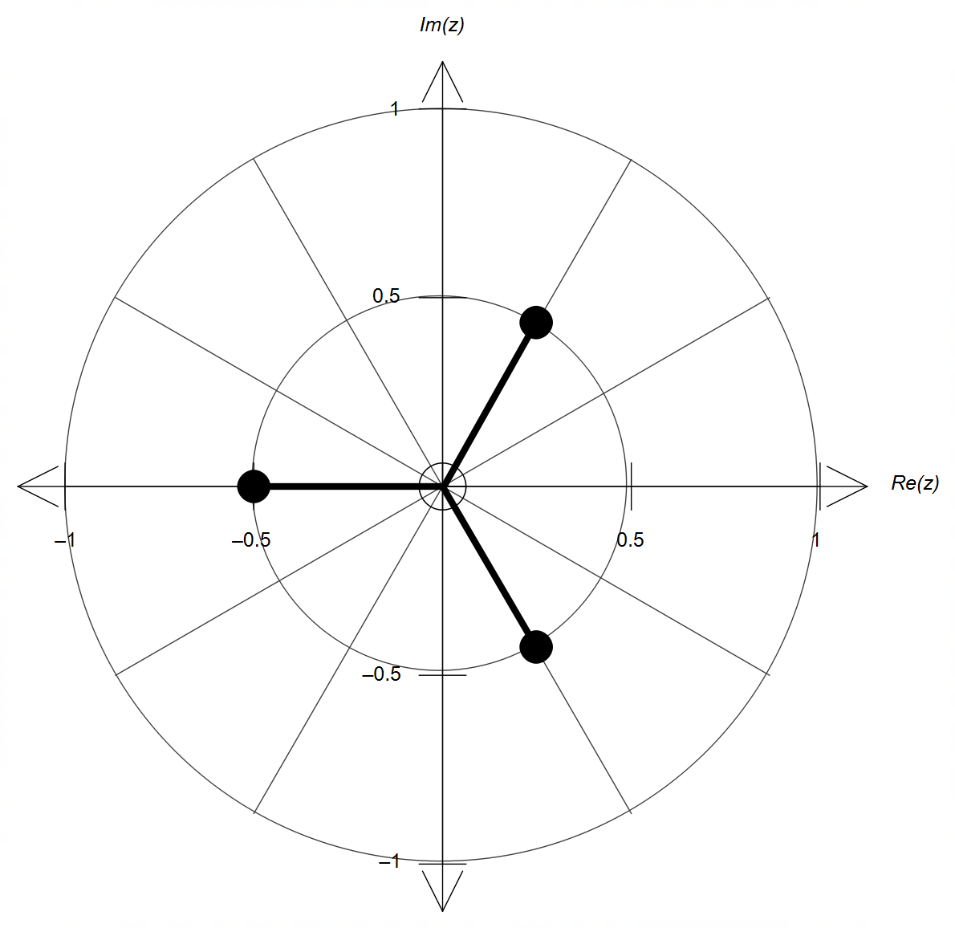

magnitude = 0.5

$\frac{2π}{3}$ radians apart

[13]
3. (a) $\begin{matrix}x+y+z=1 & …① \\ 2x+2y+z=2 & …② \\ x-2y-z=1 & …③\end{matrix}$
$②-①: x+y=1 …④$
$①+③: 2x-y=2 …⑤$
$④+⑤: 3x=3 → x=1$
$x=1 → ④: y=0$
$x=1, y=0 → ①: z=0$

(b) Entering equation into a matrix gives:
$\left[ \begin{matrix}\begin{matrix}1 & 1 \\ 2 & 2 \\ 1 & -2\end{matrix} & \begin{matrix}1 & m \\ n & 2 \\ 1 & 1\end{matrix} \end{matrix}\right]$
Using row-reduction in one step gives:
$\left[\begin{matrix}\begin{matrix}1 & 1 \\ 0 & 3 \\ 0 & 0\end{matrix} & \begin{matrix}1 & m \\ 0 & \left(m-1\right) \\ \left(2-n\right) & \left(2m-2\right)\end{matrix}\end{matrix}\right]$
From the last row: $2-n≠0 →∴n≠2$
and $m∈R$.

(c) (i) $2x-y+z=4 → r∙\left(\begin{matrix}2 \\ -1 \\ 1\end{matrix}\right)=4$
the normal to the plane is parallel to direction vector of the line,
$∴\left(\begin{matrix}a \\ b \\ c\end{matrix}\right)=k\left(\begin{matrix}2 \\ -1 \\ 1\end{matrix}\right) k∈R$
hence, accept values that are multiples of $k$ as follows:
$a=2k, b=-k, c=k k∈R$
(ii) Using $k=1$, the line becomes $r=\left(\begin{matrix}2 \\ -2 \\ 1\end{matrix}\right)+λ\left(\begin{matrix}2 \\ -1 \\ 1\end{matrix}\right)$
$∴\left(\begin{matrix}2+2λ \\ -2-λ \\ 1+λ\end{matrix}\right)∙\left(\begin{matrix}2 \\ -1 \\ 1\end{matrix}\right)=4$
$→ 7+6λ=4 → λ=-\frac{1}{2}$
$∴ r=\left(\begin{matrix}2 \\ -2 \\ 1\end{matrix}\right)-\frac{1}{2}\left(\begin{matrix}2 \\ -1 \\ 1\end{matrix}\right)=\left(\begin{matrix}1 \\ -\frac{3}{2} \\ \frac{1}{2}\end{matrix}\right)$
Coordinates of POI are $\left(1, -\frac{3}{2} ,\frac{1}{2}\right)$ [11]

4. (a) Roots: $a=1, b=-3$ or $a=-3, b=1$
Poles: $c=-1, d=-6$ or $c=-6, d=-1$
y-intercept: $f\left(0\right)=\frac{k\left(1\right)\left(-3\right)}{\left(-1\right)\left(-6\right)}=-\frac{k}{2}=1 → k=-2$
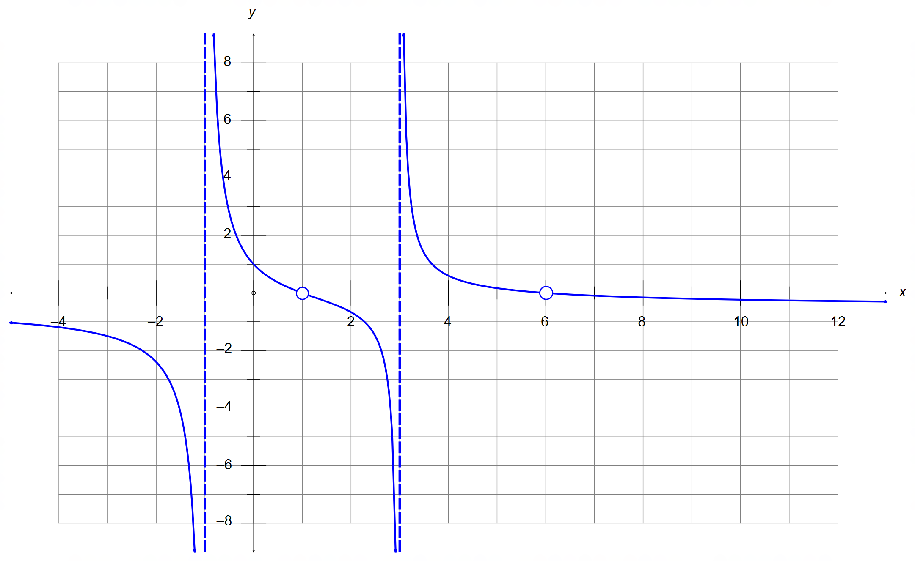
(b)
poles at x = -1,3
discontinuities at roots x = 1,6
y-intercept (0,1)
correct curvature around x = 1
correct curvature for x > 3 and x < -1

(c) $x=±3$ from symmetry over the y-axis [11]

5. (a) From the graphs:
$f\left(x\right)=0$ for $x=±2$, hence need $g\left(x\right)=±2$
but $0<g\left(x\right)<3 → g\left(x\right)=2$ only
and $g\left(x\right)=2$ for $x=-1$, and hence $k=-1$

(b) $f\left(x\right)=4-x^{2}$ and $g\left(x\right)=\sqrt{x+5}$
$gf\left(x\right)=g\left(f\right)=\sqrt{f+5}=\sqrt{9-x^{2}}$

(c) Need $f\left(x\right)≠-5$ and $f\left(x\right)≠4$
Hence, $x≠3$ and $x≠0$
$∴$ Domain $=\left\{-3<x<3 ∧ x≠0\right\}$
Range stays the same $=\left\{0<y<3\right\}$ [8]

6. (a) Centre is midpoint between P and Q = $\left(\begin{matrix}5 \\ 0 \\ 1\end{matrix}\right)$
Radius $=\frac{1}{2}\left|PQ\right|=\frac{1}{2}\left|\begin{matrix}4 \\ 2 \\ -2\end{matrix}\right|=\left|\begin{matrix}2 \\ 1 \\ -1\end{matrix}\right|=\sqrt{6}$
$∴ \left|r-\left(\begin{matrix}5 \\ 0 \\ 1\end{matrix}\right)\right|=\sqrt{6}$
(b) $\vec{PQ}$ is normal to the plane, hence $n=\vec{PQ}=\left(\begin{matrix}4 \\ 2 \\ -2\end{matrix}\right)$
$n∙PQ=\left(\begin{matrix}4 \\ 2 \\ -2\end{matrix}\right)∙\left(\begin{matrix}3 \\ -1 \\ 2\end{matrix}\right)=12-2-4=6$
$∴r∙\left(\begin{matrix}4 \\ 2 \\ -2\end{matrix}\right)=6 → 2x+y-z=3$ (simplified) [6]

Calculator−Assumed Solutions

7. Let $z=a+bi$ with $\sqrt{a^{2}+b^{2}}=4$
${\left|z+2i\right|}^{2}+{\left|z-2i\right|}^{2}$
$={\sqrt{a^{2}+{\left(b+2\right)}^{2}}}^{2}+{\sqrt{a^{2}+{\left(b-2\right)}^{2}}}^{2}$
$=\left(a^{2}+b^{2}+4b+4\right)+\left(a^{2}+b^{2}-4b+4\right)$
$=2\left(a^{2}+b^{2}\right)+8$
$=2×4^{2}+8=40$ [4]

8. (a) (i) $\vec{OA}+3\vec{OC}$ $=\left(\begin{matrix}5+3x \\ y+9 \\ -1\end{matrix}\right)$
since the z-coordinate is already of magnitude 1, then
the x ad y coordinates must be zero. Hence,
$x=-\frac{5}{3}$ and $y=-9$
(ii) $\frac{3}{2}\vec{AB}=\vec{BC}$
$∴3\left(\vec{OB}-\vec{OA}\right)=2\left(\vec{OC}-\vec{OB}\right)$
$3\vec{OB}-3\vec{OA}=2\vec{OC}-2\vec{OB}$
$5\vec{OB}=3\vec{OA}+2\vec{OC}$
$5\left(\begin{matrix}9 \\ 0 \\ -2\end{matrix}\right)=3\left(\begin{matrix}5 \\ y \\ -4\end{matrix}\right)+2\left(\begin{matrix}x \\ 3 \\ 1\end{matrix}\right)$
$\left(\begin{matrix}45 \\ 0 \\ -10\end{matrix}\right)=\left(\begin{matrix}15+2x \\ 3y+6 \\ -10\end{matrix}\right)$
$∴x=15$ and $y=-2$
(b) $\left|AB\right|=\left|\begin{matrix}0 \\ 6 \\ 0\end{matrix}\right|=6$
$\left|AC\right|=\left|\begin{matrix}-4 \\ 3 \\ α-1\end{matrix}\right|$ and $\left|BC\right|=\left|\begin{matrix}-4 \\ -3 \\ α-1\end{matrix}\right|$

If ΔABC equilateral, then $\left|AB\right|=\left|AC\right|=\left|BC\right|=6$
$∴\left|\begin{matrix}-4 \\ 3 \\ α-1\end{matrix}\right|=\left|\begin{matrix}-4 \\ -3 \\ α-1\end{matrix}\right|=6$

$4^{2}+3^{2}+{\left(α-1\right)}^{2}=6^{2}$
${\left(α-1\right)}^{2}=11 → ∴α=1±\sqrt{11}$ [10]

9. (a) $-a-2≤b<-a+2$

(b) $r≤\frac{3}{2}π ∧ -π<θ≤-\frac{2π}{3} ∧ \frac{2π}{3}≤θ≤π$

(c) $z^{2}+{\overline{z}}^{2}={\left(x+yi\right)}^{2}+{\left(x-yi\right)}^{2}$
$=x^{2}+2xyi-y^{2}+x^{2}-2xyi-y^{2}$
$=2x^{2}-2y^{2}=0$
$∴x^{2}=y^{2} → x=±y$ two lines through the origin.
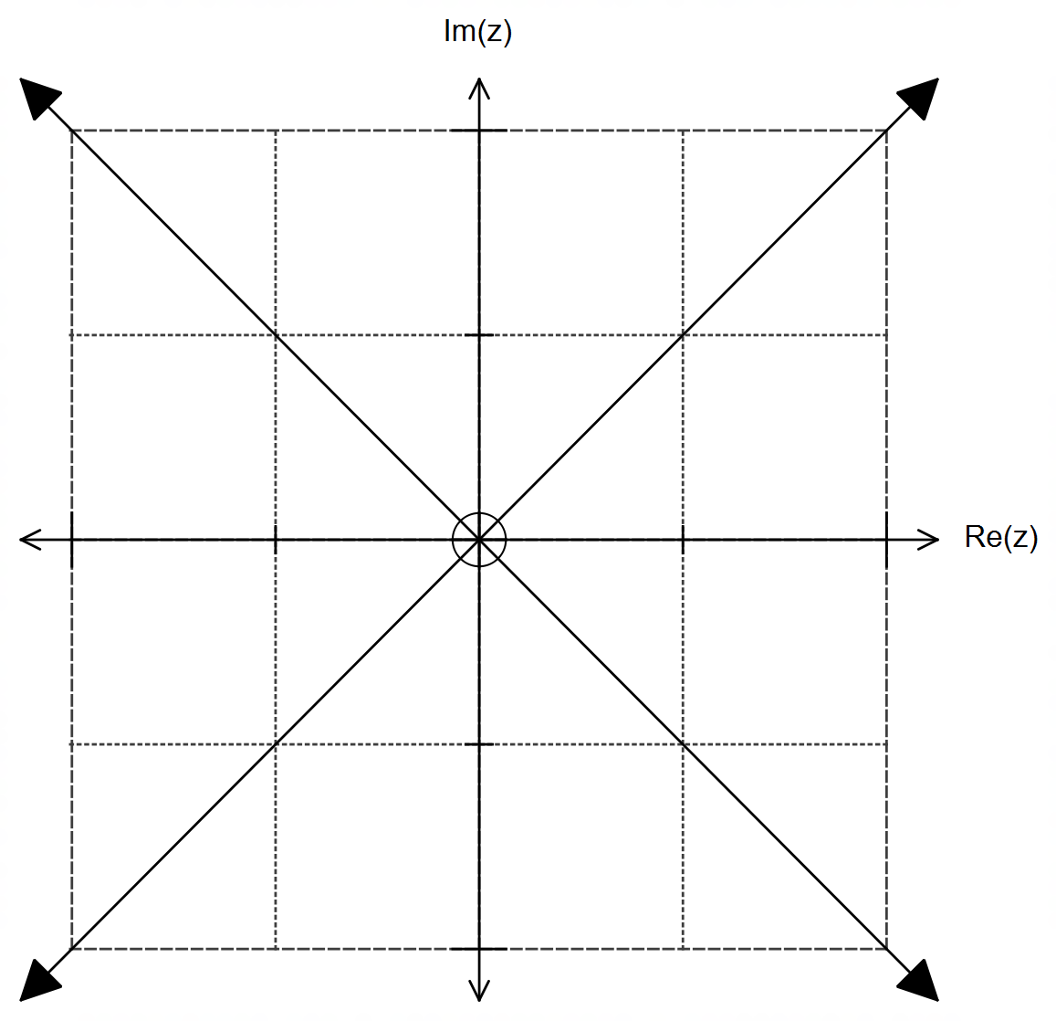

[10]
10. (a) $v=-2π\sin\left(\frac{πt}{12}\right)i+6π\cos\left(\frac{πt}{4}\right)j$
(b) $r\left(2\right)=24\cos\left(\frac{π}{6}\right)i+24\sin\left(\frac{π}{2}\right)j$
$=12\sqrt{3}i+24j≈〈20.78, 24〉$cm
$v\left(2\right)=-2π\sin\left(\frac{π}{6}\right)i+6π\cos\left(\frac{π}{2}\right)j$
$=-πi+0j=〈-π,0〉$ cm/s
$r\left(6\right)=24\cos\left(\frac{π}{2}\right)i+24\sin\left(\frac{3π}{2}\right)j$
$=0i-24j=〈0, -24〉$cm
$v\left(6\right)=-2π\sin\left(\frac{π}{2}\right)i+6π\cos\left(\frac{3π}{2}\right)j$
$=-2πi+0j=〈-2π,0〉$ cm/s
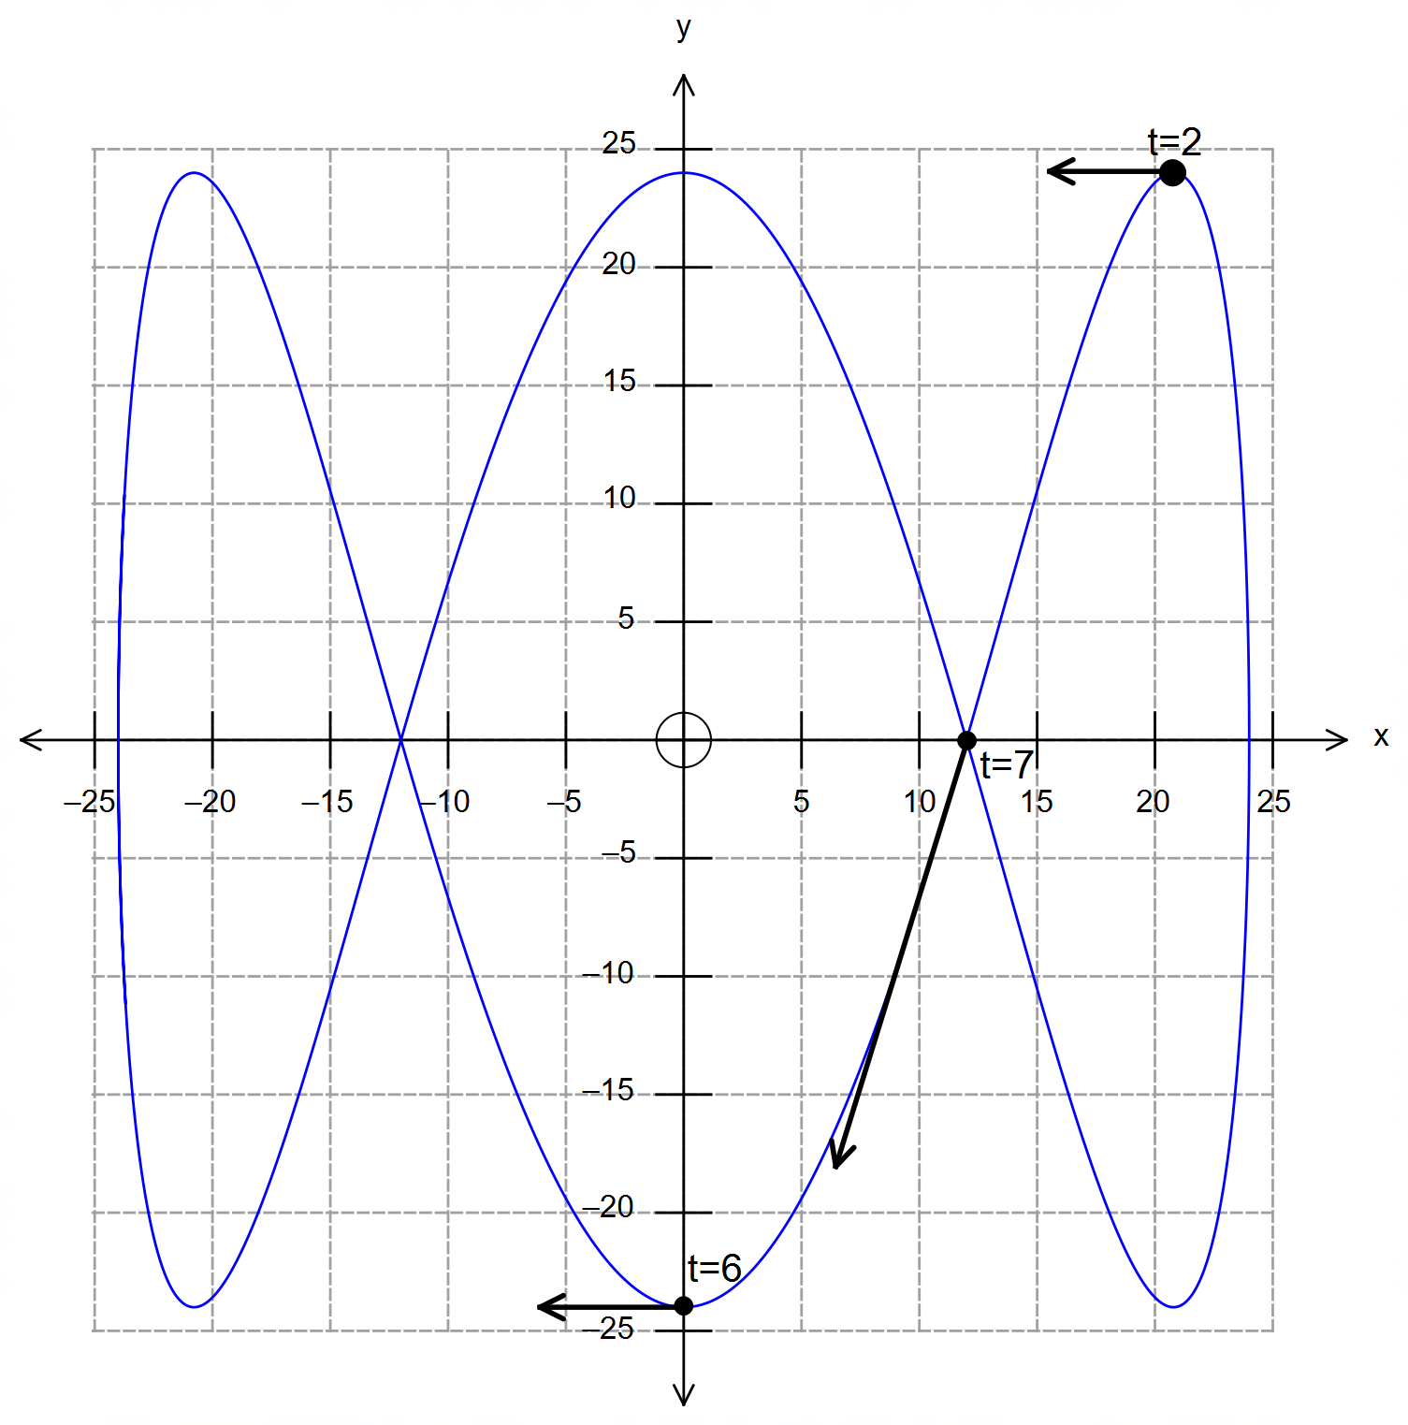

(b)

(f)

(b)

(c) $ω_{min}=\frac{π}{12} → T_{max}=\frac{2π}{ω_{min}}=\frac{2π}{π/12}=24$sec

(d) $a=-\frac{π^{2}}{6}\cos\left(\frac{πt}{12}\right)i-\frac{3π^{2}}{2}\sin\left(\frac{πt}{4}\right)j$
$∴a\left(8\right)=-\frac{π^{2}}{6}\cos\left(\frac{8π}{12}\right)i-\frac{3π^{2}}{2}\sin\left(\frac{8π}{4}\right)j=-\frac{π^{2}}{12}i$

10. (e) ${\left|v\right|}^{2}=4π^{2}\sin^{2}\left(\frac{πt}{12}\right)+36π^{2}\cos^{2}\left(\frac{πt}{4}\right)$
$∴\left|v\right|=2π\sqrt{\sin^{2}\left(\frac{πt}{12}\right)+9\cos^{2}\left(\frac{πt}{4}\right)}$

(f) CAS $→ f_{max}=19.62$ cm/s at $t=4.0203026$ s
$r\left(4.0203026\right)≈〈11.89, -0.38〉≈〈12, 0〉$ cm [17]

11. (a) $f\left(x\right)=\left|4-\left|x\right|\right|$ OR $f\left(x\right)=\left|\left|x\right|-4\right|$

(b) $g\left(x\right)=-\left|x+2\right|+2 → a=b=2$

(c) $0≤m<\frac{1}{3}$
$0<n≤\frac{20}{7}$ [8]

12. (a) $v=4\operatorname{cis}\left(\frac{π}{5}\right)$ and $w=3\operatorname{cis}\left(-\frac{3π}{10}\right)$
(i) $\frac{1}{2}v×w=\frac{1}{2}×12\operatorname{cis}\left(\frac{π}{5}-\frac{3π}{10}\right)=6\operatorname{cis}\left(-\frac{π}{10}\right)$
(ii) $v^{-1}×8w=\frac{8w}{v}=24\operatorname{cis}\left(-\frac{3π}{10}\right)÷4\operatorname{cis}\left(\frac{π}{5}\right)$
$=6\operatorname{cis}\left(-\frac{π}{2}\right)$
(iii) $\frac{v}{i^{3}}=4\operatorname{cis}\left(\frac{π}{5}\right)÷{cis}^{3}\left(\frac{π}{2}\right)=4\operatorname{cis}\left(\frac{π}{5}-\frac{3π}{2}\right)=4\operatorname{cis}\left(\frac{7π}{10}\right)$

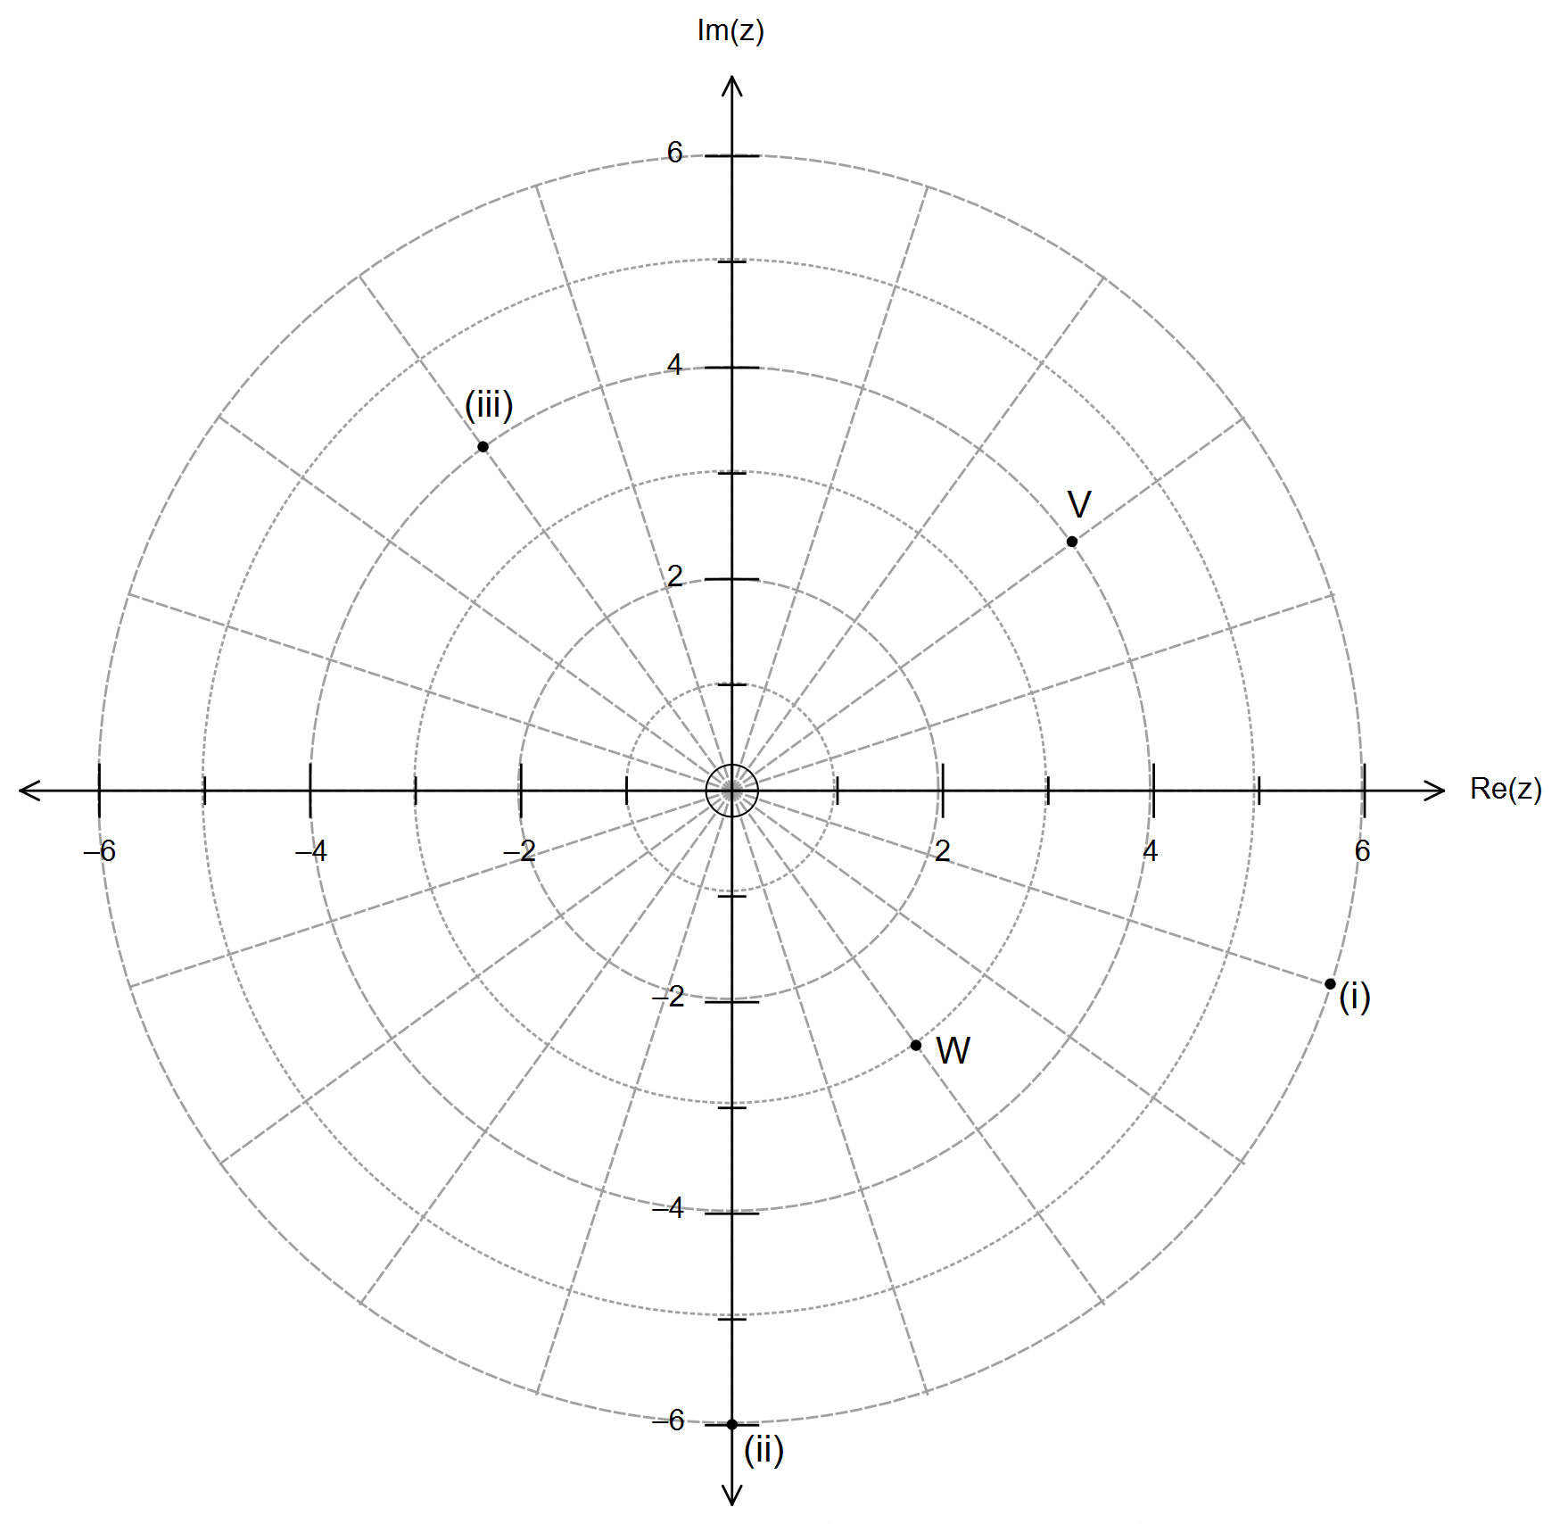

12. (b) (i) ${\left|z\right|}_{max}$ and ${\left|z\right|}_{min}$ occur along the line connecting the
centre of the circle with the origin.
$\left|\begin{matrix}2 \\ 1\end{matrix}\right|=\sqrt{5}$
$∴{\left|z\right|}_{max}=4+\sqrt{5}$ and ${\left|z\right|}_{min}=4-\sqrt{5}$

(ii) ${\left(x-2\right)}^{2}+{\left(y-1\right)}^{2}=16$ and $Re\left(z\right)=x=4$
$∴4+{\left(y-1\right)}^{2}=16 → y=1±\sqrt{12}$
$∴\arg\left(z\right)=\tan^{-1}\left(\frac{1±\sqrt{12}}{4}\right)={0.8402}^{R} or -{0.5521}^{R}$ [12]

13. (a) Speed $=\left|\begin{matrix}25 \\ -12 \\ 2\end{matrix}\right|=\sqrt{773}≈27.80$ m/s
$\left(\begin{matrix}25 \\ -12 \\ 2\end{matrix}\right)∙\left(\begin{matrix}25 \\ -12 \\ 0\end{matrix}\right)=\left|\begin{matrix}25 \\ -12 \\ 2\end{matrix}\right|×\left|\begin{matrix}25 \\ -12 \\ 0\end{matrix}\right|×\cos{θ}$
$∴\cos{θ}=\frac{769}{\sqrt{769×773}} → θ=4.13°$

(b) $15\min{=900 s}$
$\vec{OB}\left(900\right)=900\left(\begin{matrix}25 \\ -12 \\ 2\end{matrix}\right)=\left(\begin{matrix}22500 \\ -10800 \\ 1800\end{matrix}\right)$
$\vec{RB}=\vec{OB}-\vec{OR}=\left(\begin{matrix}22500 \\ -10800 \\ 1800\end{matrix}\right)-\left(\begin{matrix}6400 \\ -12500 \\ 300\end{matrix}\right)=\left(\begin{matrix}16100 \\ 1700 \\ 1500\end{matrix}\right)$
Distance $=\left|\begin{matrix}16100 \\ 1700 \\ 1500\end{matrix}\right|=100\left|\begin{matrix}161 \\ 17 \\ 15\end{matrix}\right|=100\sqrt{26435}≈16 258.84$ m

(c) $\vec{OB}\left(960\right)=960\left(\begin{matrix}25 \\ -12 \\ 2\end{matrix}\right)=\left(\begin{matrix}24000 \\ -11520 \\ 1920\end{matrix}\right)$
$\vec{OR}\left(960\right)=\left(\begin{matrix}6400 \\ -12500 \\ 300\end{matrix}\right)+960\left(\begin{matrix}x \\ y \\ z\end{matrix}\right)=\left(\begin{matrix}24000 \\ -11500 \\ 1920\end{matrix}\right)$
$∴\left(\begin{matrix}x \\ y \\ z\end{matrix}\right)=\frac{1}{60}\left(\begin{matrix}24000-6400 \\ -11520+12500 \\ 1920-300\end{matrix}\right)=\left(\begin{matrix}293.\overline{3} \\ 16.\overline{3} \\ 27\end{matrix}\right)$ m/s
at $1,920$ m above level ground.

(d) distance $=\left|\begin{matrix}24000 \\ -11520 \\ 1920\end{matrix}\right|≈26 690.76 m$, $∴v=\frac{26690.76}{343}=77.82 s$ [12]

14. (a) $\frac{1}{z}=\frac{1}{\cos{θ}+i\sin{θ}}×\frac{\cos{θ}-i\sin{θ}}{\cos{θ}-i\sin{θ}}=\frac{\cos{θ}-i\sin{θ}}{\cos^{2}{θ}+\sin^{2}{θ}}=\cos{θ}-i\sin{θ}$

(b) $z^{n}+z^{-n}=2\cos\left(nθ\right) → \cos\left(nθ\right)=\frac{z^{n}+z^{-n}}{z}$
$z^{n}-z^{-n}=2i\sin\left(nθ\right) → \sin\left(nθ\right)=\frac{z^{n}-z^{-n}}{2i}$

(c) $\cos\left(2θ\right)=\frac{z^{2}+z^{-2}}{2}$ and $\sin\left(4θ\right)=\frac{z^{4}-z^{-4}}{2i}$

(d) $\cos\left(2θ\right)×\sin\left(4θ\right)=\left(\frac{z^{2}+z^{-2}}{2}\right)×\left(\frac{z^{4}-z^{-4}}{2i}\right)$
$=\frac{1}{4i}\left(z^{6}-z^{-2}+z^{2}-z^{-6}\right)$
$=\frac{1}{2}\left(\frac{z^{6}-z^{-6}}{2i}\right)+\frac{1}{2}\left(\frac{z^{2}-z^{-2}}{2i}\right)$
$=\frac{1}{2}\sin\left(6θ\right)+\frac{1}{2}\sin\left(2θ\right)$ [9]

15. (a) $f^{-1}\left(x\right)$ does not exist because $f\left(x\right)$ is not a one-to-one function.
(b) (i) Need $π≤x≤2π$, hence $k=π$
Then, $f^{-1}\left(x\right)=π+\cos^{-1}\left(1-x\right)$
(ii) Domain $=\left\{0≤x≤2\right\}$ and Range $=\left\{π≤y≤2π\right\}$
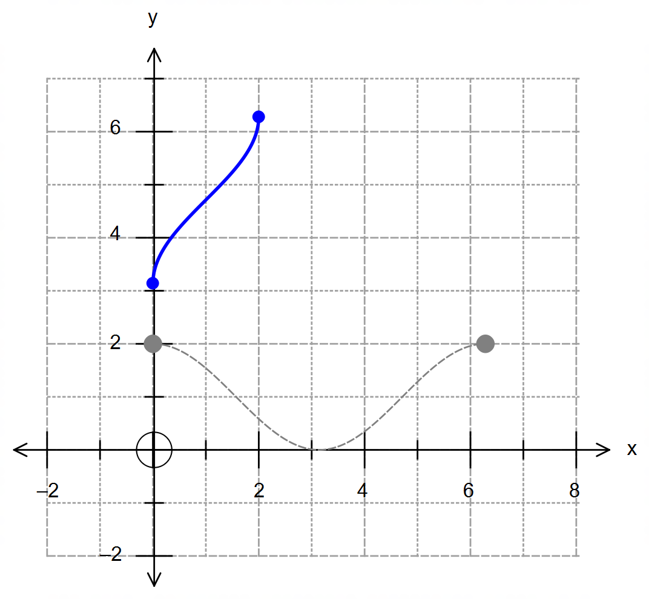 (c)

sinusoidal and symmetrical over the line y=x

correct location and boundaries (accuracy)

(d) $gf\left(f^{-1}\right)=g\left(x\right)$
$∴ g\left(x\right)=gf\left(f^{-1}\right)=f^{-1}+1=π+\cos^{-1}\left(x-1\right)+1$ [10

16. $x=\cos\left(2θ\right)=\cos^{2}{θ}-\sin^{2}{θ}=2\cos^{2}{θ}-1$
$∴\cos^{2}{θ}=\frac{x+1}{2}$
Similarly,
$x=\cos\left(2θ\right)=\cos^{2}{θ}-\sin^{2}{θ}=1-2\sin^{2}{θ}$
$∴\sin^{2}{θ}=\frac{1-x}{2}$
and $y=\tan{θ}$, and for domain to remain the same:
$y^{2}=\tan^{2}{θ}=\frac{\sin^{2}{θ}}{\cos^{2}{θ}}=\frac{1-x}{2}÷\frac{x+1}{2}$

Hence, $y^{2}=\frac{1-x}{x+1}$ [5]

(Other methods are possible depending on their choice of trigonometric
identity. Award marks accordingly).

